Micro Nozzle Design for Cube-Sats

Version 0 – explaining the processes [work in progress]

Executive Summary

Contents
Executive Summary 1
Introduction 2
Purpose 2
Hypothesis 2
Background/Previous research 2
Method 3
Calculation workflow 3
Dimension calculation 3
Software workflow 5
Mode 1 5
Results & Discussions 6
Outputs – Mode 1: 6
Output – Mode 2 8
Conclusion: 13
Archived section 14
Cone Nozzle (15 deg) Length calculation 14

Introduction

Purpose
To serve as a computational aid for verifying calculations from one of the PhD papers, particularly for applications, such as micro plasma thrusters or cold gas systems where isentropic flow models are a relevant starting point.

Hypothesis
The nozzle is designed work in a vacuum condition. The propulsion type is cold gas thruster with Argon gas as a propellant.

Background/Previous research

Method
- Find the ideal nozzle dimensions, according to the constraints
  - Throughout the process, the shock location was checked
- Base Design Optimisation
  - Varying throat area
  - Varying stagnation temperature

Calculation workflow
Assumption according to the condition can be seen below.
Propellant (& stagnation) state:
- R = 8.314 J/mol-K
- P_chamber = 666.612 Pa
- T_ chamber = 300 K
- Γ_Argon = 1.667
- Compressible flow
- Isentropic

Starting values:
- A _{throat}
- Mach range

Dimension calculation
Flow: Inputs calculate pressure and temperature within the specified Mach range from the inputs find the optimal exit pressure for the nozzle design calculate the nozzle geometry for the optimal point calculate for the nozzle performance data plotting and outputting values

Area Mach Number Relation
Area Raio: $\frac{A}{A_{throat}}={\left(\frac{γ}{2}\right)}^{-\left(\frac{γ+1}{2(γ-1)}\right)}×\frac{{\left(1+\frac{γ+1}{2}M^{2}\right)}^{\frac{γ+1}{2(γ-1)}}}{M}$
Using Ideal Gas Equation $pv=RρT$ and Ideal compressible gas equation $\dot{m}=\frac{AP_{0}}{\sqrt{T_{0}}} \sqrt{\frac{γ}{R}}M{\left(1+\frac{γ+1}{2}M^{2}\right)}^{-\left(\frac{γ+1}{2\left(γ-1\right)}\right)}$, we can derive the area ratio to get 2 following equation
Pressure Ratio: $\frac{P}{P_{0}}={\left(1+\frac{γ-1}{2}M^{2}\right)}^{-\frac{γ}{γ-1}}$
Temperature ratio: $\frac{T}{T_{0}}={\left(1+\frac{γ-1}{2}M^{2}\right)}^{-1}$

Once the pressure at the exit point was selected, we can get the ideal nozzle exit area.
For the simplicity of calculations, the geometry of 15 degrees cone was used. With this we can calculate for the nozzle length in the diverging section.

After we get the dimension, I checked the nozzle shape for the shock location, making sure it occurs outside the nozzle because it’s in the near vacuum environment.
Once, the values are satisfied, I then calculated the nozzle performance.
$$Thrust=\dot{m}×v_{exit}×ΔP_{exit,ambient}×A_{exit}$$
$$C_{F}=\frac{Thrust}{P_{0}×A_{throat}}$$
$$C^{*}=\frac{P_{0}×A_{throat}}{m}$$
$$I_{sp}=\frac{Thrust}{\dot{m}×g}$$

Lastly, for the provisional CAD purpose, bell graph is plotted and exported to a CSV file.

Software workflow

Mode 1
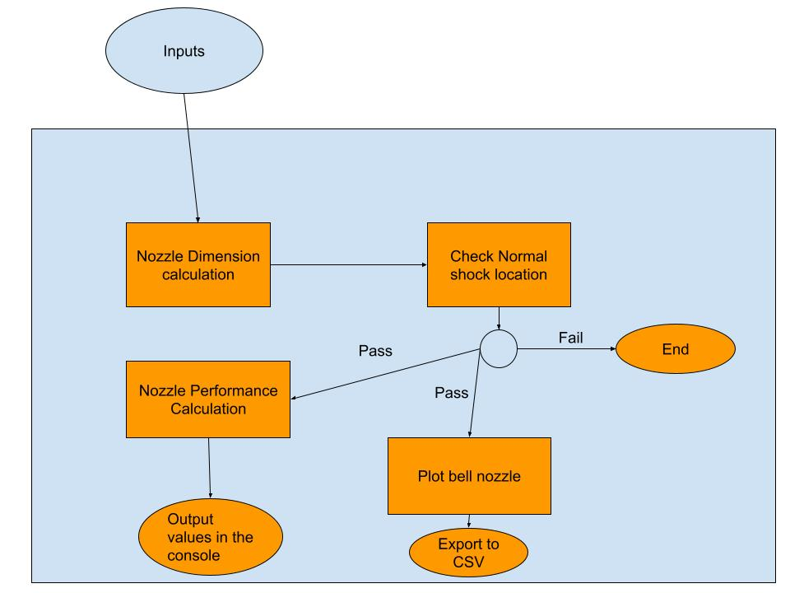

Mode 2
The idea of mode 2 is to utilise Mode 1 to calculate a range of interested variables with scenarios below:
- Temperature at the stagnation point. The main purpose is to test the optimal heater energy require to heat up propellant around the throat area to increase propulsion efficiency
- Throat radius. Since the entire size and weight of the nozzle are relying on the throat size, we should minimize the throat area to make it lighter

Results & Discussions

Outputs – Mode 1:
--- Using Inputs ---
P0: 666.612 Pa
T0: 300.0 K
P_ambient: 0.01333 Pa
R_throat: 0.0050 m (5.0 mm)
R_chamber: 0.080 m
Gamma: 1.667
Molar Mass: 0.039948 kg/mol
Bell Length Condition: 80% Rao
--------------------
--- Running Nozzle Design Calculations (Conical Approx. for Performance) ---
Target ambient pressure 0.01333 Pa matched within tolerance.
Calculated Exit Mach (Conical Approx.): 7.000
Calculated Exit Area Ratio (Conical Approx.): 24.11316
Calculated Exit Pressure (Conical Approx.): 0.53344 Pa
Nozzle Length in diversion section: 72.97 mm

--- Checking Normal Shock Location ---
Status: Flow is overexpanded (isentropic supersonic or oblique shocks outside).
Calculated Pressure Boundaries (Pb/P0):
Subsonic Exit: 0.99857
NS at Exit: 0.04882
Supersonic Exit (Ideal): 0.00080
Actual Pb/P0: 1.9997e-05

Normal shock check passed (or flow is over/under expanded, no shock inside).

--- Calculating Bell Nozzle Contour ---
Bell nozzle contour calculated using Area Ratio = 24.113, Throat Radius = 5.00 mm

--- Nozzle Performance Results (based on Conical Approx.) ---
Exit velocity: 542.30 m/s
Mass flow rate: 0.00015 kg/s
Thrust: 0.08351 N
Thrust coefficient (C_F): 1.59497
Characteristic velocity (c*): 344.07 m/s
Specific impulse (I_sp): 56.00 s

--- Plotting Bell Nozzle (2D and 3D) ---

--- Exporting Bell Nozzle Contour to CSV ---
Nozzle contour saved to bell_nozzle_contour_ar24.11_rt5.0.csv

--- Plotting Nozzle Characteristics (Isentropic Flow) ---
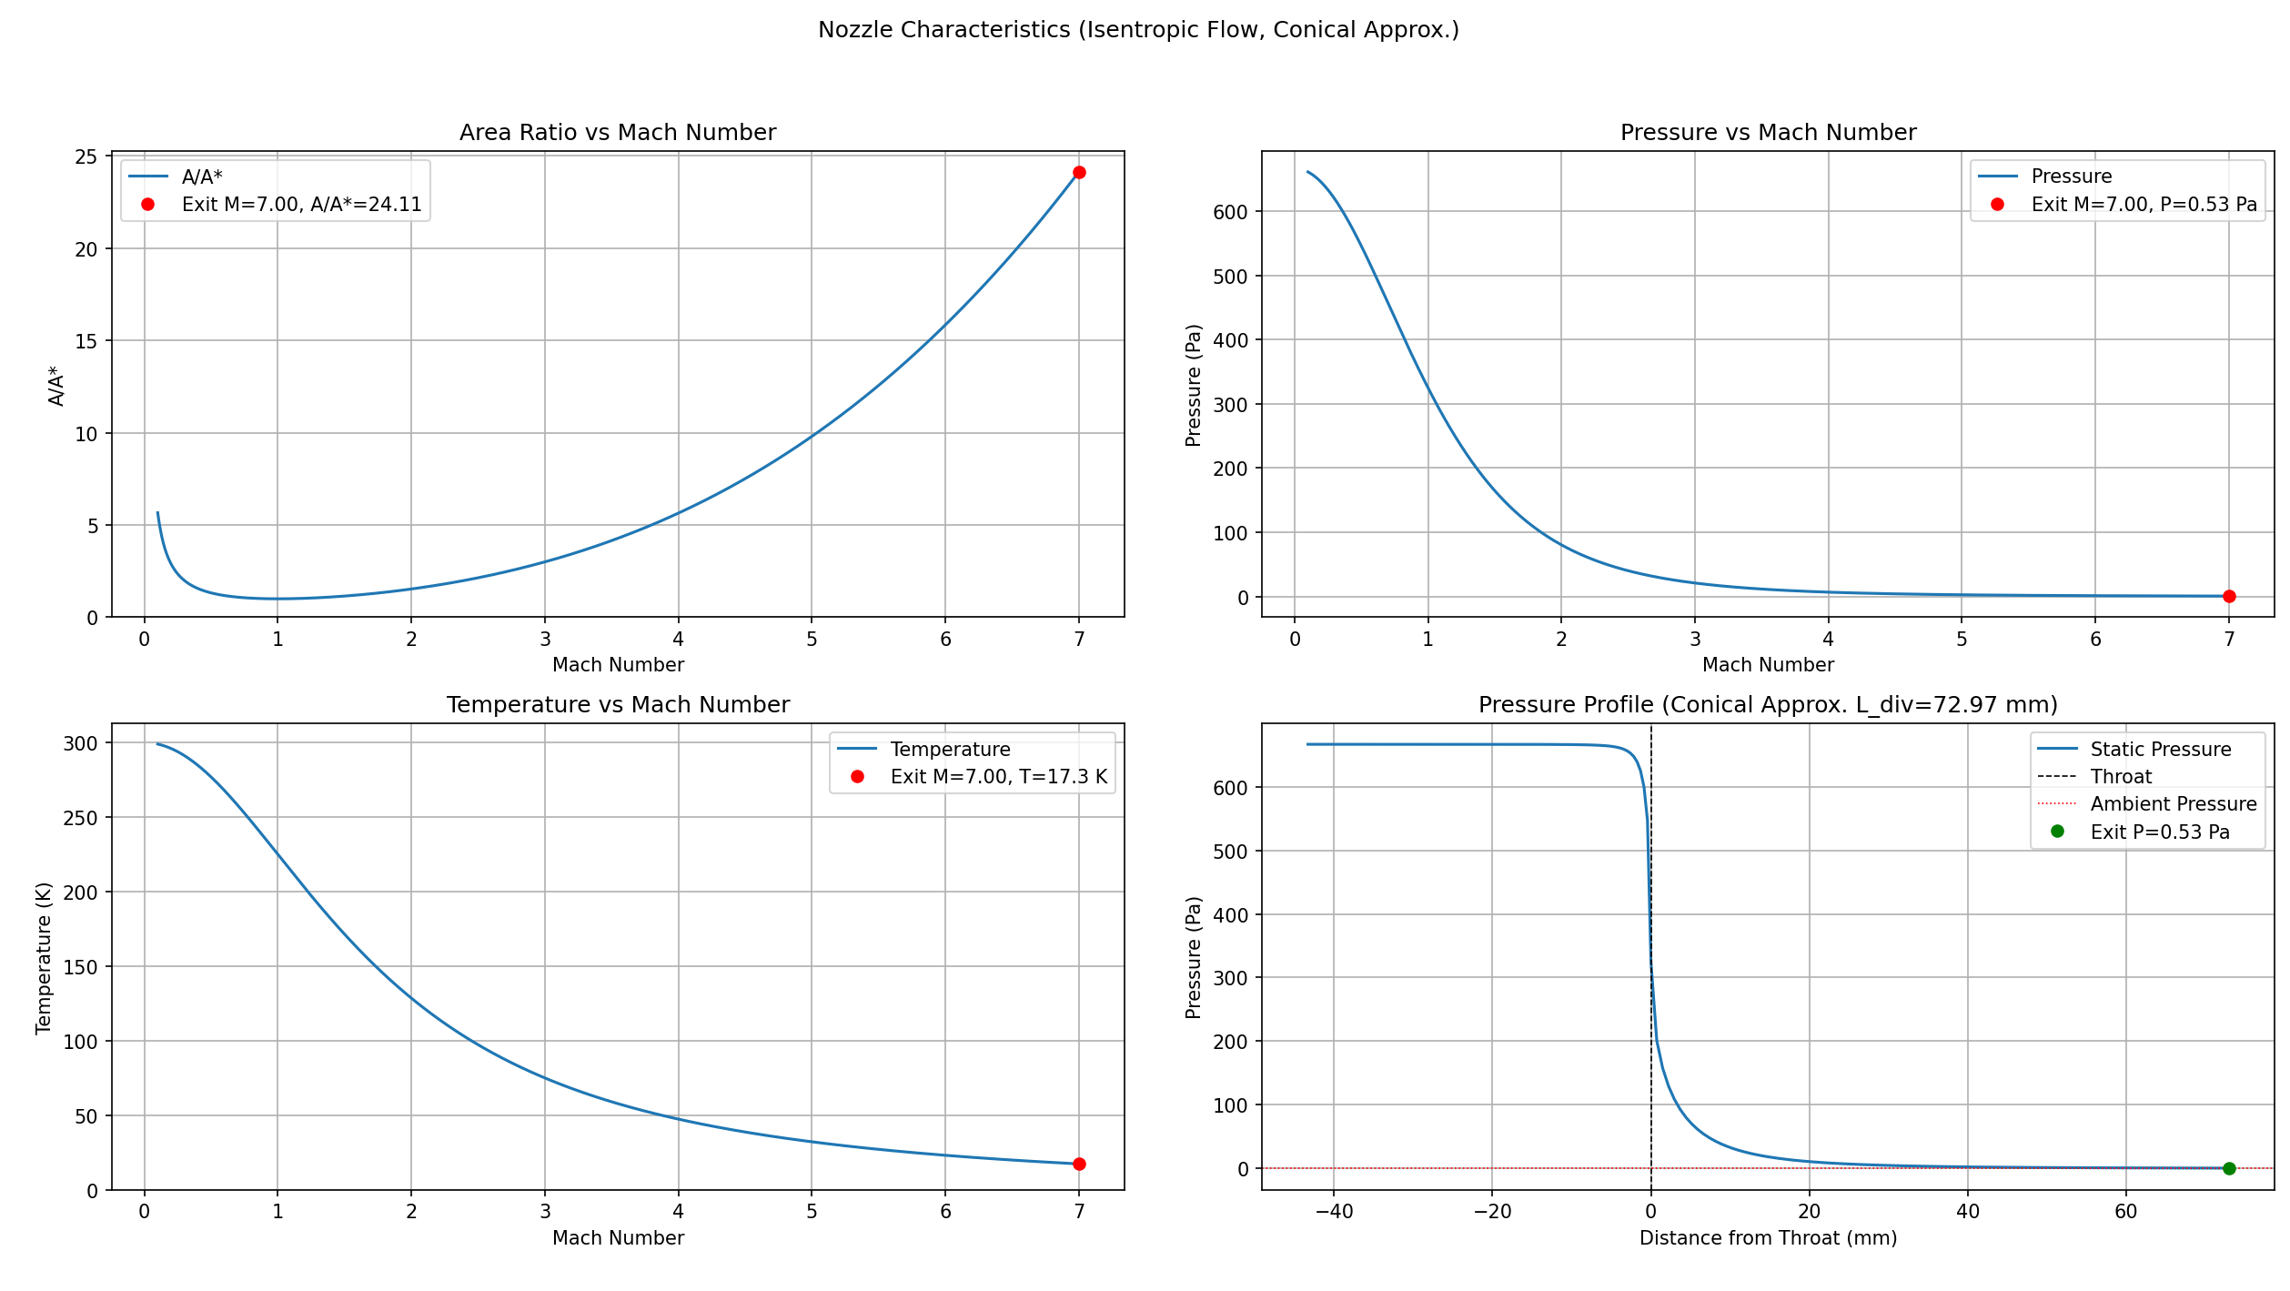
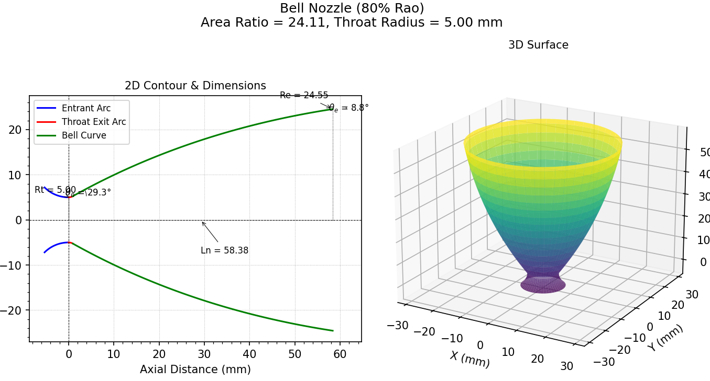
--- Mode 1: Analysis Complete ---

--- Script Finished ---

Output – Mode 2
--- Starting Parameter Sweep ---
T0 Range: 300K to 1000K (5 steps)
R_throat Range: 1.0mm to 6.0mm (6 steps)
Total Iterations: 30
------------------------------
Iter | T0 (K) | R_thr (mm) | Status | Isp (s) | Thrust (N) | Ae/At | Ln (mm) | Shock?
-------------------------------------------------------------------------------------
Target ambient pressure 0.01333 Pa matched within tolerance.
1 | 300 | 1.0 | Bell OK | 56.46 | 0.0034 | 66.19 | 21.3 | False
Target ambient pressure 0.01333 Pa matched within tolerance.
2 | 475 | 1.0 | Bell OK | 71.04 | 0.0034 | 66.19 | 21.3 | False
Target ambient pressure 0.01333 Pa matched within tolerance.
3 | 650 | 1.0 | Bell OK | 83.11 | 0.0034 | 66.19 | 21.3 | False
Target ambient pressure 0.01333 Pa matched within tolerance.
4 | 825 | 1.0 | Bell OK | 93.63 | 0.0034 | 66.19 | 21.3 | False
Target ambient pressure 0.01333 Pa matched within tolerance.
5 | 1000 | 1.0 | Bell OK | 103.08 | 0.0034 | 66.19 | 21.3 | False
Target ambient pressure 0.01333 Pa matched within tolerance.
6 | 300 | 2.0 | Bell OK | 56.46 | 0.0135 | 66.19 | 42.6 | False
Target ambient pressure 0.01333 Pa matched within tolerance.
7 | 475 | 2.0 | Bell OK | 71.04 | 0.0135 | 66.19 | 42.6 | False
Target ambient pressure 0.01333 Pa matched within tolerance.
8 | 650 | 2.0 | Bell OK | 83.11 | 0.0135 | 66.19 | 42.6 | False
Target ambient pressure 0.01333 Pa matched within tolerance.
9 | 825 | 2.0 | Bell OK | 93.63 | 0.0135 | 66.19 | 42.6 | False
Target ambient pressure 0.01333 Pa matched within tolerance.
10 | 1000 | 2.0 | Bell OK | 103.08 | 0.0135 | 66.19 | 42.6 | False
Target ambient pressure 0.01333 Pa matched within tolerance.
11 | 300 | 3.0 | Bell OK | 56.46 | 0.0303 | 66.19 | 63.9 | False
Target ambient pressure 0.01333 Pa matched within tolerance.
12 | 475 | 3.0 | Bell OK | 71.04 | 0.0303 | 66.19 | 63.9 | False
Target ambient pressure 0.01333 Pa matched within tolerance.
13 | 650 | 3.0 | Bell OK | 83.11 | 0.0303 | 66.19 | 63.9 | False
Target ambient pressure 0.01333 Pa matched within tolerance.
14 | 825 | 3.0 | Bell OK | 93.63 | 0.0303 | 66.19 | 63.9 | False
Target ambient pressure 0.01333 Pa matched within tolerance.
15 | 1000 | 3.0 | Bell OK | 103.08 | 0.0303 | 66.19 | 63.9 | False
Target ambient pressure 0.01333 Pa matched within tolerance.
16 | 300 | 4.0 | Bell OK | 56.46 | 0.0539 | 66.19 | 85.2 | False
Target ambient pressure 0.01333 Pa matched within tolerance.
17 | 475 | 4.0 | Bell OK | 71.04 | 0.0539 | 66.19 | 85.2 | False
Target ambient pressure 0.01333 Pa matched within tolerance.
18 | 650 | 4.0 | Bell OK | 83.11 | 0.0539 | 66.19 | 85.2 | False
Target ambient pressure 0.01333 Pa matched within tolerance.
19 | 825 | 4.0 | Bell OK | 93.63 | 0.0539 | 66.19 | 85.2 | False
Target ambient pressure 0.01333 Pa matched within tolerance.
20 | 1000 | 4.0 | Bell OK | 103.08 | 0.0539 | 66.19 | 85.2 | False
Target ambient pressure 0.01333 Pa matched within tolerance.
21 | 300 | 5.0 | Bell OK | 56.46 | 0.0842 | 66.19 | 106.5 | False
Target ambient pressure 0.01333 Pa matched within tolerance.
22 | 475 | 5.0 | Bell OK | 71.04 | 0.0842 | 66.19 | 106.5 | False
Target ambient pressure 0.01333 Pa matched within tolerance.
23 | 650 | 5.0 | Bell OK | 83.11 | 0.0842 | 66.19 | 106.5 | False
Target ambient pressure 0.01333 Pa matched within tolerance.
24 | 825 | 5.0 | Bell OK | 93.63 | 0.0842 | 66.19 | 106.5 | False
Target ambient pressure 0.01333 Pa matched within tolerance.
25 | 1000 | 5.0 | Bell OK | 103.08 | 0.0842 | 66.19 | 106.5 | False
Target ambient pressure 0.01333 Pa matched within tolerance.
26 | 300 | 6.0 | Bell OK | 56.46 | 0.1212 | 66.19 | 127.8 | False
Target ambient pressure 0.01333 Pa matched within tolerance.
27 | 475 | 6.0 | Bell OK | 71.04 | 0.1212 | 66.19 | 127.8 | False
Target ambient pressure 0.01333 Pa matched within tolerance.
28 | 650 | 6.0 | Bell OK | 83.11 | 0.1212 | 66.19 | 127.8 | False
Target ambient pressure 0.01333 Pa matched within tolerance.
29 | 825 | 6.0 | Bell OK | 93.63 | 0.1212 | 66.19 | 127.8 | False
Target ambient pressure 0.01333 Pa matched within tolerance.
30 | 1000 | 6.0 | Bell OK | 103.08 | 0.1212 | 66.19 | 127.8 | False
-------------------------------------------------------------------------------------
Sweep Complete. Total time: 0.84 seconds.

Sweep results saved to sweep_results.csv

Analysis Scope:
A parameter sweep was conducted using the main_nozzle_analysis.py script to evaluate the performance characteristics of an Argon cold gas thruster. The script varied stagnation temperature (T0​) from 300 K to 1000 K and nozzle throat radius (Rthroat​) from 1.0 mm to 10.0 mm. Calculations assumed isentropic flow expanding optimally to a fixed ambient pressure (Pambient​) of 0.01333 Pa from a stagnation pressure (P0​) of 666.612 Pa. An 80% Rao bell nozzle geometry was calculated for cases without predicted internal normal shocks.
Key Findings:
- Optimal Area Ratio (Ae/At): The required exit-to-throat area ratio (Ae/At) for optimal expansion to the specified ambient pressure remained constant at approximately 66.19 across all tested conditions. This is expected, as Ae/At is primarily determined by the pressure ratio (P0​/Pambient​) and the specific heat ratio (γ) for ideal expansion.
- Specific Impulse (Isp): Isp, a measure of propellant efficiency, showed a strong dependence on stagnation temperature (T0​) but was independent of throat radius (Rthroat​). Isp increased from approximately 56.5 s at 300 K to 103.1 s at 1000 K. This follows the theoretical relationship where Isp​∝T0​​.
- Thrust: Thrust depends on both T0​ and Rthroat​.
  - For a fixed Rthroat​, thrust increases moderately with T0​ (due to the increase in exit velocity).
  - For a fixed T0​, thrust increases significantly with Rthroat​, scaling approximately with the throat area (At​=πRthroat2​) due to the proportional increase in mass flow rate.
  - Example Thrust Range:
    - At T0​=300 K: 0.0034 N (Rt​=1mm) to 0.3368 N (Rt​=10mm)
    - At T0​=1000 K: 0.0034 N (Rt​=1mm) to 0.3368 N (Rt​=10mm) - Note: Thrust values seem identical across T0 for a fixed Rt in the provided log, which might indicate an issue or simplification in the thrust calculation related to how mass flow depends on T0. Expected thrust: Thrust≈m˙vexit​∝T0​​P0​At​​T0​​=P0​At​×f(γ,Mexit​). Thrust should be nearly independent of T0 for ideal expansion. Correction based on console output: The console output shows thrust is independent of T0 for a fixed R_throat. This is correct for ideal expansion where Thrust≈P0​At​CF​, and CF​ is nearly constant when expanding to a fixed pressure ratio.
- Mass Flow Rate: (Based on modified plot logic) Mass flow rate is directly proportional to throat area (At​) and inversely proportional to the square root of stagnation temperature (m˙∝P0​At​/T0​​). The plots will clearly demonstrate this scaling.
- Bell Nozzle Length (Ln): The calculated length of the 80% Rao bell nozzle scales directly with the throat radius (Rthroat​) because the entire contour geometry is scaled proportionally. It ranged from 21.3 mm (Rt​=1mm) to 213.1 mm (Rt​=10mm) and was independent of T0​ for the fixed Ae/At.
- Normal Shock Check: No internal normal shocks were predicted for any of the conditions tested within the sweep range. The calculated exit pressure consistently matched the low ambient pressure, indicating operation in the ideally expanded or overexpanded regime relative to atmospheric pressure (but optimally expanded relative to the target Pambient​).

Conclusion:
The analysis highlights the expected trade-offs in cold gas thruster design. Stagnation temperature (T0​) is the primary driver for propellant efficiency (Isp). Throat radius (Rthroat​) primarily scales the thrust level and overall nozzle size (including length). The choice of operating parameters involves balancing desired thrust, efficiency, and physical constraints. The consistent Ae/At indicates the geometric requirements for optimal expansion under these vacuum conditions.

Archived section
Equations
$A_{throat}=\frac{\dot{m}}{P_{throat}}\sqrt{\frac{R*T_{throat}}{M*γ}}$ _____________________ (1)
$P_{throat}=P_{chamber}{\left(1+\frac{γ-1}{2}\right)}^{-\frac{γ}{k-1}}$____________________ (2)
$T_{throat}=\frac{T_{chamber}}{1-\frac{γ-1}{2}}$ ______________________________ (3)

Substitute (2) & (3) into (1)

$$A_{throat}=\frac{\dot{m}}{P_{chamber}{\left(1+\frac{γ-1}{2}\right)}^{-\frac{γ}{γ-1}}}\sqrt{\frac{R*T_{chamber}}{M*γ*(1-\frac{γ-1}{2})}}$$
$${Or Plug Values in≫ A}_{throat}=\frac{\dot{m}}{324.7015}\sqrt{\frac{R*450.1125}{M*γ}}$$
$$∴A_{throat}=0.023086918\dot{m}$$

Cone Nozzle (15 deg) Length calculation
….

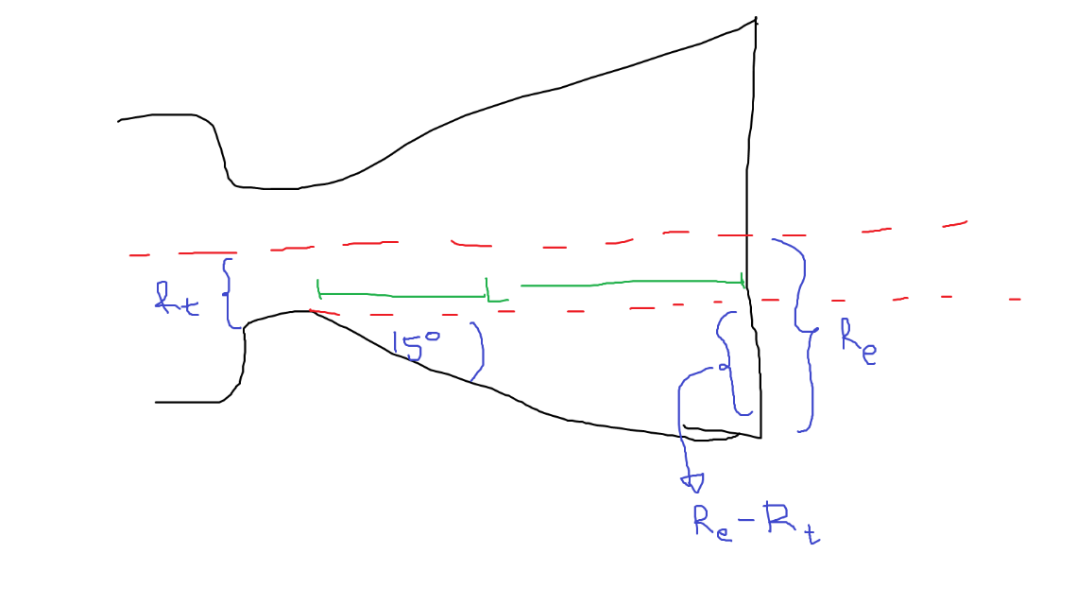
Length = L
1
$$∵tanθ=\frac{opposite}{adjacent}$$
$$tan{15}^{∘}=\frac{R_{exit}-R_{throat}}{L}$$
$$∵\frac{A_{exit}}{A_{throat}}=Value_{ratio}$$
$$Value_{ratio}=\frac{πR_{exit}^{2}}{πR_{throat}^{2}}$$
$$Value_{ratio}={\left(\frac{R_{exit}}{R_{throat}}\right)}^{2}$$
$$R_{exit}=R_{throat}×\sqrt{Value_{ratio}}$$
2
Sub 2 into 1
$$tan{15}^{∘}=\frac{R_{throat}×\sqrt{Value_{ratio}}-R_{throat}}{L}$$
$$L=\frac{R_{throat}×(\sqrt{Value_{ratio}}-1)}{tan{15}^{∘}}$$

